To begin completing the worksheet click **File** in the top left-hand corner and then choose **Make A Copy.**

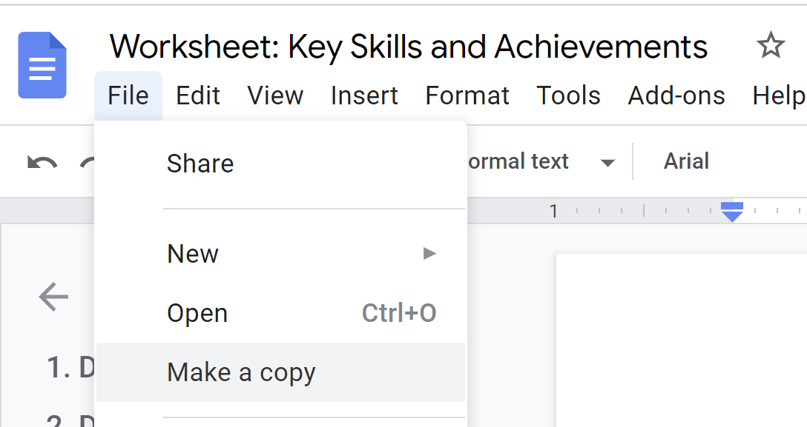

**Part 1: Adding numbers to your CV/Resume**

**Questions to help you along:**

1. Number of people you worked with?
2. Number of people you managed?
3. Number of products/projects you managed?
4. Attendance record % (90+)?
5. Number of people you presented to?
6. Number of people in group project?
7. Number of people you surveyed?
8. Increased social media following by?
9. Words you can type per minute?
10. Number of calls/emails answered per day/week?
11. Positive Google reviews received?

**Part 2: Remembering your biggest wins**

**When writing out the answers do your best to explain:**

* What you did
* How you did it
* The result

**1. How did you perform in the school/academic environment?**

* How did you excel? Did you lead a team or project? Get exceptional results on an assignment? Take on extracurricular activities? Complete an industry-based assignment? Win an award? Get selected for something? Undertake additional studies? Mentor other students? Deliver presentations to large crowds? Conduct any research?
* What was the result? Recognition from a lecturer? Strong results on the assignment/subject? Additional skills? Improved marks? What is your strongest subject in school?

**2. Targets**

* Think about a time in school or college where you had specific targets to reach - such as a group project assignment or upcoming exams.
* Did you achieve them? How did you achieve them?

**3. Are you an active member of any clubs or organisations?**

* What do you do at the club? Do you work with others? Do you take ownership or lead anyone? Did you organise anything? What have you achieved with the club?

**4. Have you ever learned a new skill in your spare time?**

* What did you learn? How did you learn it? What was the outcome?

**5. Have you ever taught someone a new skill?**

* Did you train someone to learn how to use technology? (App, website, software tool)
* Did you ever help someone study for an exam, or provide advice or guidance on a particular subject?
* Did you research different methods or study materials to help teach others?

**6. Do you have any technical skills?**

* For example: Microsoft Office suite (Word, PowerPoint, Excel, Teams), Zoom, Mac and Windows operating systems, Adobe Suite (Photoshop, Premiere Pro), Google Tools (Analytics, Data Studio, AdWords), social media platforms (TikTok, Instagram, Twitter, Facebook).

**7. Have you ever volunteered?**

* For example:
  + At school (fundraising, selling tickets, helping at events, etc.)
  + At a charity (collecting clothes/food/toys) Raised money for a cause? Delivered leaflets? Worked with a team to reach a certain fundraising target?

**8. Public speaking**

* Have you ever delivered a presentation in front of your class? What technologies did you use to create and deliver the presentation (PowerPoint/Animation software/YouTube)
* Did you take questions from teachers/students/examiners?
* Have you ever performed in front of a crowd? (Acting in a school play, delivering a speech at en event)

**9. Are you physically fit?**

* What is your fitness regime? How do you balance sports/studies/extracurricular activities?

**10. What is the hardest you have ever worked?**

* For example - Managing multiple responsibilities simultaneously; Exams, project deadlines, personal development, sports, volunteering, club membership, etc.

**11. Did you create something new?**

* What did it do and what value did it bring?

**12. Did you solve a problem?**

* Think of a time when you went above and beyond your call of duty to find a solution to a problem?

**13. Did you come up with or improve an idea?**

* What did it do and what was its benefit?

**14. Did you help with something important or contribute to a key project?**

* What did the team or project achieve and what benefit did that bring to the organisation?

**15. Were you selected for something important or did you win an award or receive recognition?**

* What did you do that was recognised as valuable?

**16. Did you excel in something?**

* Did you hold a perfect attendance record? Juggle multiple priorities? Score well on a test? Lead a team? (Captain/vice captain)

**17. Service: Did you improve services?**

* How did you improve services? Did you create new service training? Perform better follow-up? Provide more personalised service? Improve service solutions?
* What was the result?

**18. Quality: Did you improve quality?**

* How did you improve quality? Did you increase work checks? Create better training or systems? Improve planning?
* What was the result?

**19. Administration: Did you improve administration or improve a process?**

* Did you improve records management systems? Did you create new templates? Did you bring in new computing systems?
* What was the result? More professional communications? Quicker access to records?

**20. Productivity: Did you improve productivity?**

* How did you improve productivity? Did you set up new training or systems? Provide clearer KPIs? Reorganise duties? Created a project plan?
* What was the result?

**21. Doing a good job**

* Think about examples of times you've earned praise from others.
* What did you do, and what made it so good?

**22. Additional responsibilities**

* Have you ever taken on additional duties? What was the outcome?